Practical School with WQeMS

(for professionals) – Water Europe
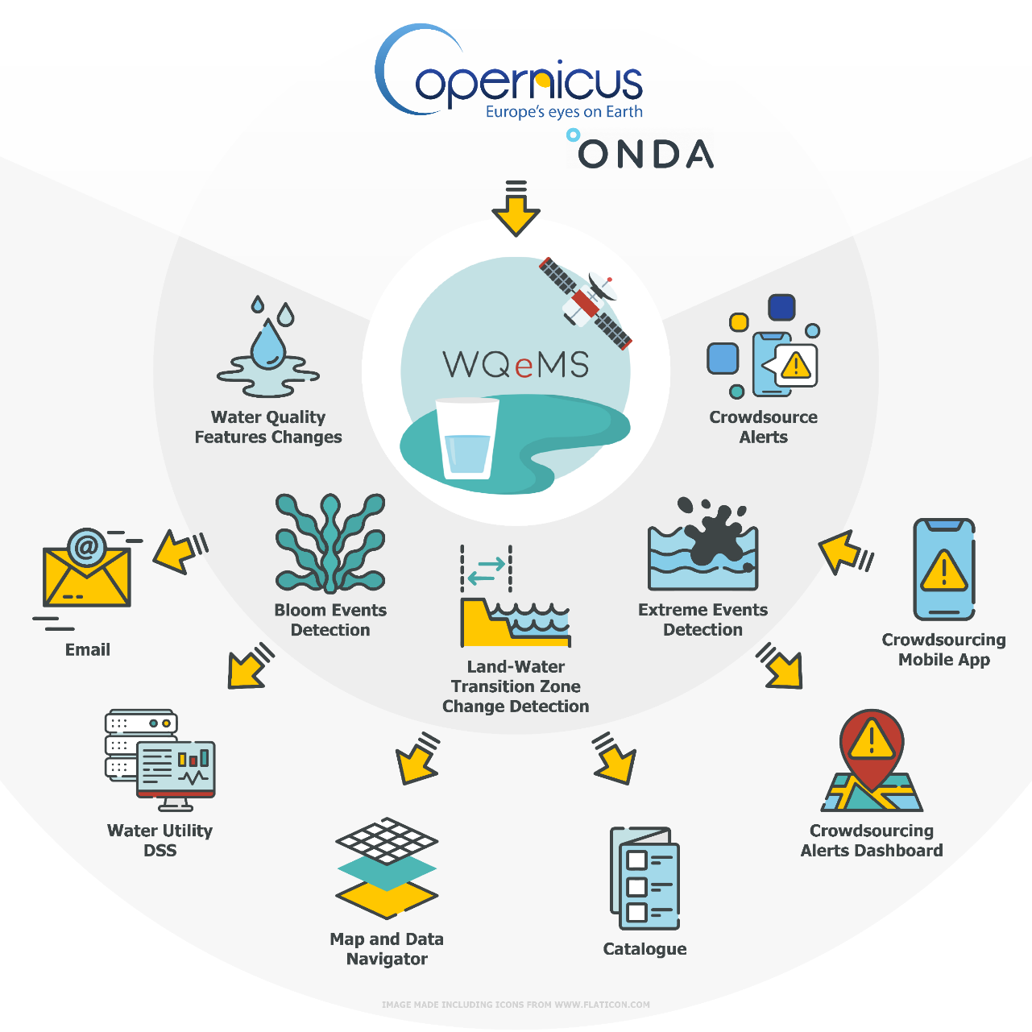
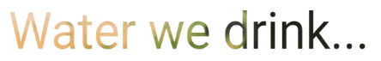 | Online webinar: Thursday, June 29, 2023, 10:00 -12:00 (CEST)
 | Tools: your PC or laptop!
 | Objectives:

Visualize the service components and demonstrate the WQeMS platform:

-- Guided Hands-on experience –

The user in the centre

AGENDA
 | Wednesday, 29 June
Practical School with WQeMS
(for professionals) – Water Europe
From - To |  | Topic |  |  | Speaker/ Panel | Expected outcome
10:00- 10:05 |  | Welcome and presentation of the agenda |  |  | Andrea Rubini (Water Europe) | Gain insight about the structure of the guided hands-on experience
10:20- 10:35 |  |  | The WQeMS Platform |  | Matteo Basile (ENG) | A brief overview for the enhancement of understanding
10:35- 11:30 |  | Online demonstration and hands on experience |  | Matteo Basile (ENG) |  |  | Real examples of services exploitation and their benefits follow me mode!
11:30-11:35 |  | Quality of Experience |  | George Milis (PHOEBE) |  |  | What do you think about our services and products?
11:35- 11:45 |  | Capacity Building |  | George Millis (PHOEBE) |  |  | Capacity building free for all!
11:45-12:00 |  | Open Discussion |  | Naomi Timmer (Water Europe WG Human Capital Leader) |  |  | Discussion time, if needed

